Summary of Parallelized computational 3D video microscopy of freely moving organisms by Zhou et al. 2023
  - Gaurang Garg
  - PhD Scholar

1. Citation
Zhou, K.C., Harfouche, M., Cooke, C.L. et al. Parallelized computational 3D video microscopy of freely moving organisms at multiple gigapixels per second. Nat. Photon. 17, 442–450 (2023).

2. Summary of Contents

2.1. Paper Type
This paper presents a technological development and computational algorithm paired with extensive biological application studies. It introduces a new hardware-software hybrid architecture for 3D microscopy.

2.2. Problem Description
Conventional wide-field microscopes are limited by the space-bandwidth product (SBP), creating a strict trade-off between spatial resolution and the field of view (FOV). Furthermore, existing 3D imaging techniques (like light-sheet or optical coherence tomography) typically require sequential scanning or multiple snapshot measurements. This compromises temporal resolution, making it nearly impossible to capture the high-speed 3D kinematics of multiple freely moving organisms across a large area.

2.3. What is it?
The paper presents 3D-RAPID (3D Reconstruction with an Array-based Parallelized Imaging Device). It is a computational microscope built on a Multi-Camera Array Microscope (MCAM) architecture. Using an array of 54 synchronized micro-cameras, it captures gigapixel-scale videos. The system uses a novel self-supervised Convolutional Neural Network (CNN) algorithm to simultaneously stitch these 54 images together and extract 3D height maps using stereoscopic parallax cues and ray-propagation physics.

2.4. Study Design
- Optical Architecture and Integration: The hardware consists of a $9 ×6$ array of cameras with finite-conjugate lenses ($f = 26.23$ mm) configured for a magnification of $M ≈0.11$. Crucially, the lenses are spaced to ensure a ~66% overlap in the horizontal FOV between adjacent cameras. This overlap redundancy provides the stereoscopic parallax cues required for 3D estimation.
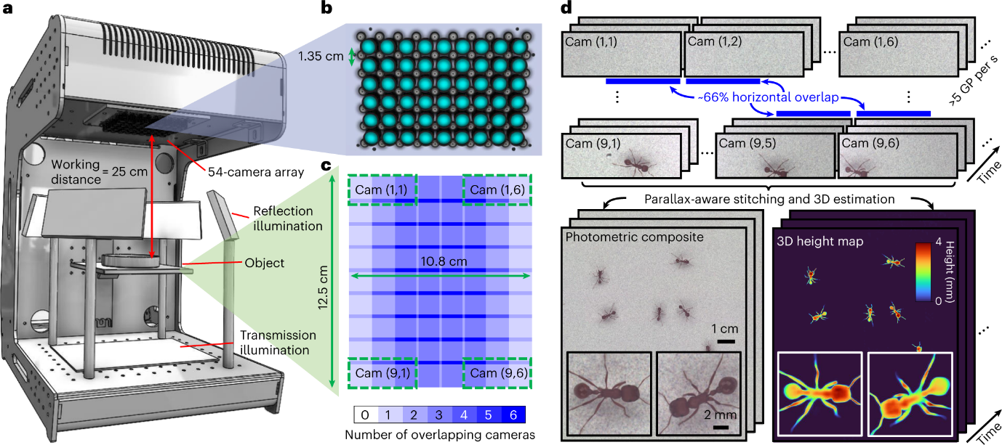
Figure 1 a, Computational microscope setup. b, The 9 × 6 array of cameras and lenses. c, Overlap map of the object plane. d, The MCAM captures 54 synchronized videos at throughputs of >5 GP per s, and these are stitched to form a high-speed video sequence of globally consistent composites and the corresponding 3D height maps.
- Computational Algorithm: Instead of iteratively optimizing the 3D height map for every single frame, the researchers parameterized the height map as the output of an encoder-decoder CNN. The network uses a ray-based thin-lens physical model to orthorectify the overlapping images. The network is trained self-supervised, using only the photometric error between the warped images in the overlapping regions as a loss function.
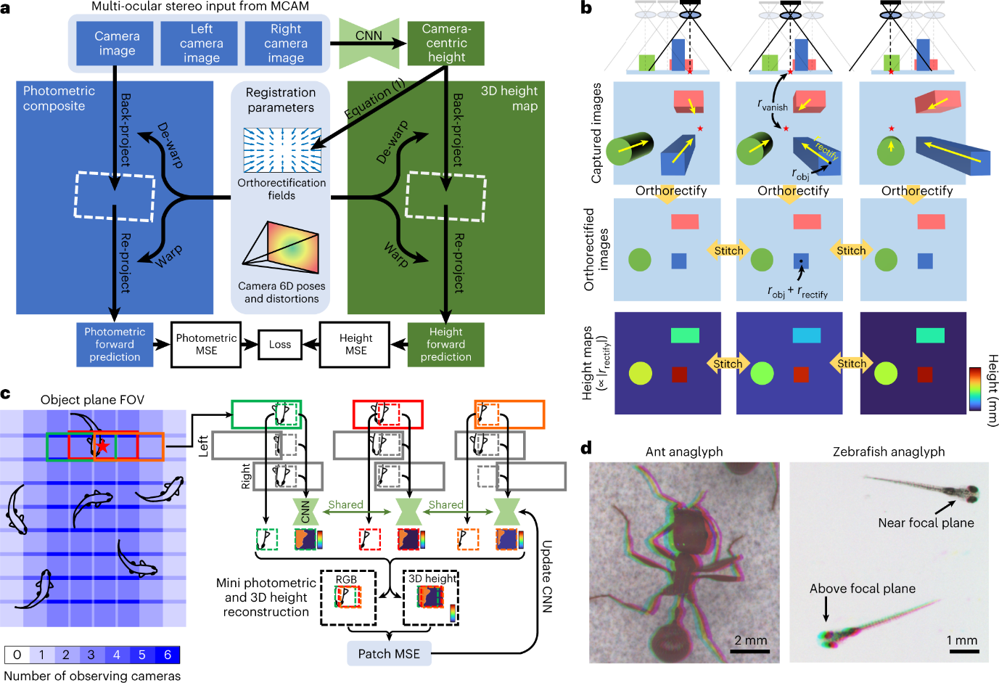
Figure 2 a Computational Architecture. b, The physical ray model and orthorectified fields. c, The patch-based joint training/stitching/3D reconstruction algorithm. d, Anaglyphs.
- Optical Benchmarking: Before biological imaging, the system's geometric and photometric parameters (6D pose, distortion, intensity variations) were calibrated using a flat, patterned target. They verified height accuracy using precisely machined gauge blocks, achieving sub-20 µm accuracy at 15 frames per second (fps).
- In Vivo Behavioural Imaging: The system's utility was tested on three unconstrained model organisms across a 135 cm² arena:
  - Zebrafish Larvae: Tracked 3D feeding behaviours and eye-vergence angles at 60 and 230 fps.
  - Fruit Flies: Tracked changes in head, thorax, and abdomen height to classify specific 3D grooming behaviours.
  - Harvester Ants: Mapped the 3D kinematics of the femur-tibia joints on all six legs to study high-frequency alternating tripod gaits during free exploration.

2.5. Results
The 3D-RAPID system successfully captured continuous 3D topographic videos over a 135 cm² area with spatial resolutions down to ~25 µm. The hardware achieved a spatiotemporal data rate exceeding 5 gigapixels per second. The computational pipeline successfully generated seamless photometric composites and co-registered 3D height maps, uncovering complex behavioural kinematics (like the correlation between zebrafish elevation angle and eye vergence) that are invisible to standard 2D macroscopes.

2.6. Conclusion
By merging multi-camera array hardware with a physics-informed, self-supervised CNN, 3D-RAPID overcomes traditional SBP limits. It enables high-throughput, high-resolution 3D behavioral monitoring of multiple organisms simultaneously, entirely removing the need for physical restraints or sequential scanning.

3. Abstract
Observing the complex, three-dimensional kinematics of freely moving organisms is highly constrained by the space-bandwidth product of traditional optical systems, which forces a compromise between FOV, spatial resolution, and temporal speed. Here, we present 3D-RAPID, a computational microscopy platform that captures 3D topographic video over a massive 135 cm² area at speeds up to 230 fps. Utilizing a 54-camera array generating over 5 gigapixels of data per second, the system relies on a self-supervised convolutional neural network to stitch images and estimate 3D height maps. By using stereoscopic overlap and a ray-propagation physical model as the sole training supervision, the algorithm scales to arbitrarily long videos without requiring ground-truth datasets. The platform's efficacy is demonstrated by tracking the 3D locomotion and behavioral kinematics of freely exploring zebrafish, fruit flies, and ants.

4. Novelty
The primary novelty lies in the algorithmic approach to data fusion: formulating 3D height extraction and image stitching as a single, joint optimization problem solved by a physics-supervised Deep Image Prior (DIP). Instead of calculating depth frame-by-frame, the CNN learns the physical ray-propagation model of the specific camera array. This allows it to perform non-iterative forward inference for subsequent video frames, achieving extreme spatiotemporal compression and making gigapixel 3D video computationally feasible.

5. Limitations and Criticism
Understand and describe the shortcomings of the technology or study discussed in the paper.

6. Your final thoughts
Subjectively evaluate the paper and present your views as a summary here. (Example: The relevance of the paper in your research or anything you could have done differently to realise those objectives).

